Digitalized Implementation and Supervisory Remote Control for Structural Material Bend Deflection Testing over IoT
Noise and Vibration Harshness (NVH) Laboratory, Vellore Institute of Technology (VIT), Chennai
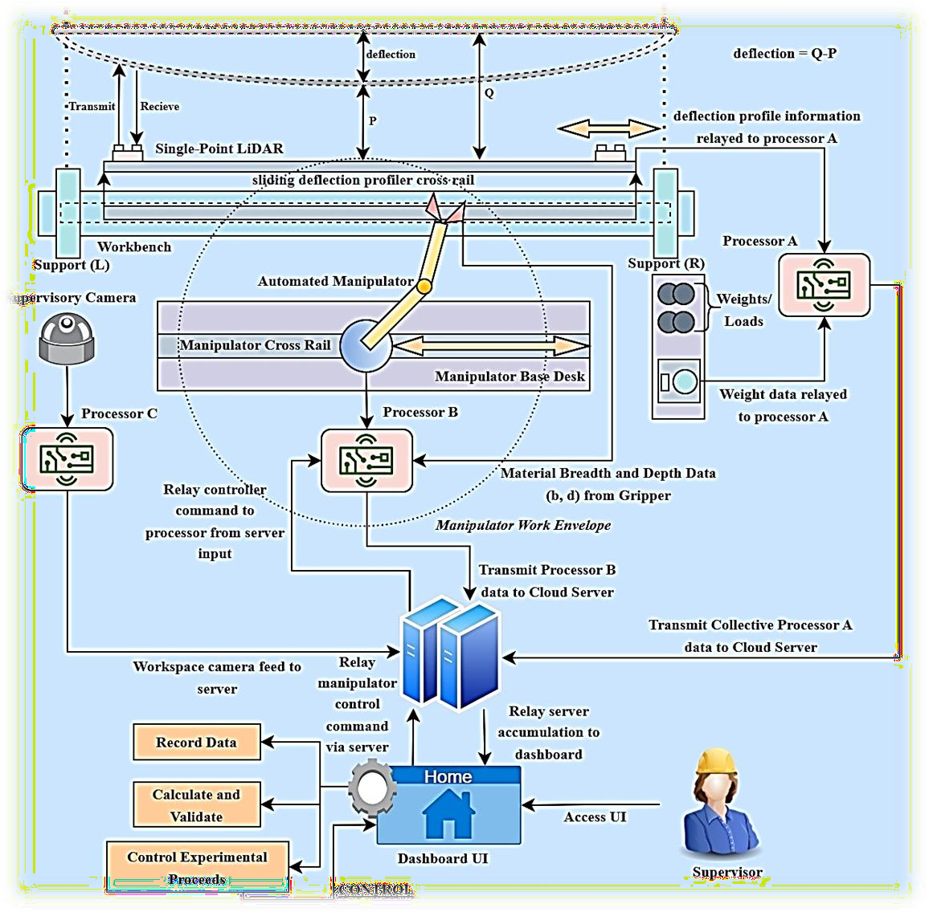

Project Mentor

Dr. Lenin Babu

Developer Team – Mechatronics and Automation
Sriker Y.S. – 21BMH1204

Vinod Vasan – 21BMH1053

Project Objective:

  - To develop a digitally twinned setup encompassing a remote operation and supervision of an originally manually operated bend-deflection experimental construction.
  - To blend technological disruptions in the front of robotic manipulators, server-side computation and the Internet of Things over requisite communication protocols to achieve aforementioned goal.

Phase 1 – Proceedings of Prima Facie Development

- Progress Overview:
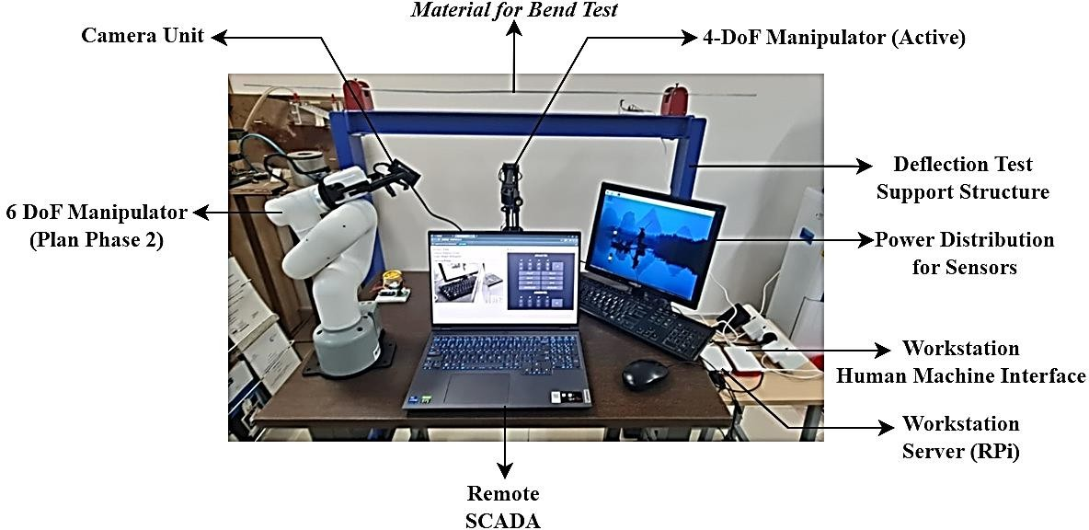

Figure 1 – Overview of Present (Phase 1) Setup

  - The overall project timeline has been bifurcated into three phases. Presently, phase 1 of the project has been achieved.
  - As an outcome of this phase, a workstation including requisite hardware and firmware deployments to achieve required sensing and actuation functionalities has been setup.
  - A remote system is used to access the workstations server which hosts all the system controls.
  - A robotic manipulator (presently, with four degrees of freedom), is controlled remotely from the remote (SCADA) station.

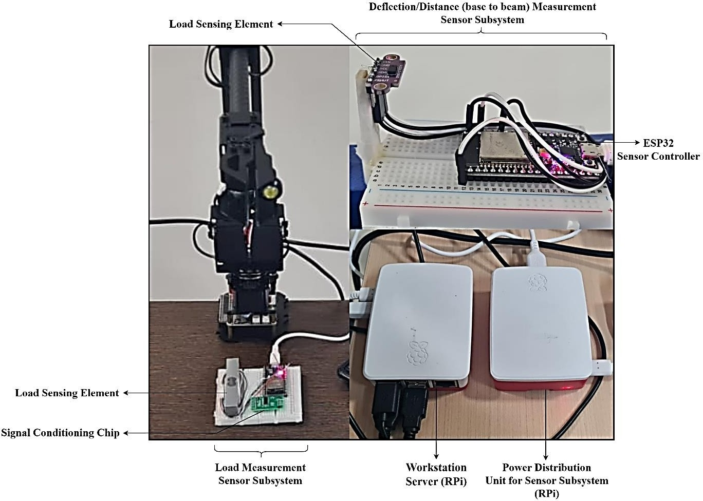
Figure 2 – Sensory and Power Distribution System Overview (Phase 1 Setup)

  - The SCADA station also accesses the input from a load sensor, and a deflection/distance measurement (Time-of-Flight) sensor from the setup, remotely.
  - No active wiring between the server at the workstation and the remote SCADA has been employed
  - The sensor data, along with a live reduced-latency video feed, along with the robotic control interface is infused into a singular webpage which is accessed using the SCADA system.
  - Thus, the robotic manipulator for lifting test weights, deflection and load measuring sensor setups and a camera communicate with a raspberry Pi server, which then sources the information to the remote SCADA system connected to said Pi over SSH.
  - Thus, as a successful outcome, a Local Area Network (LAN) encompassing a central network connection with the server, robotic manipulator, sensor subsystems (including respective controllers) and the remote SCADA system (all connected to the same, said central network) has been constituted.
  - WebSocket and MQTT communication protocols have been presently and successfully adopted for the present phase of implementation.

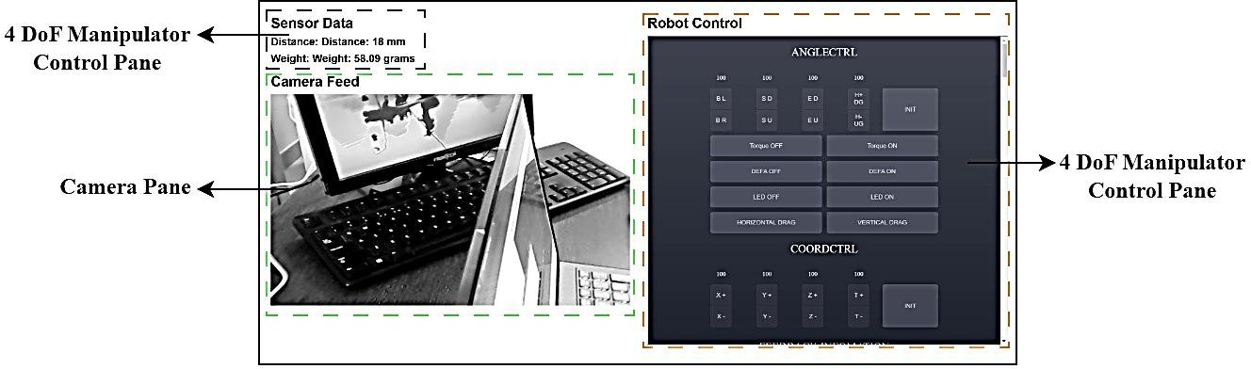

Figure 3 – Overview of the presently deployed User Interface (UI)

Phase 2 Roadmap
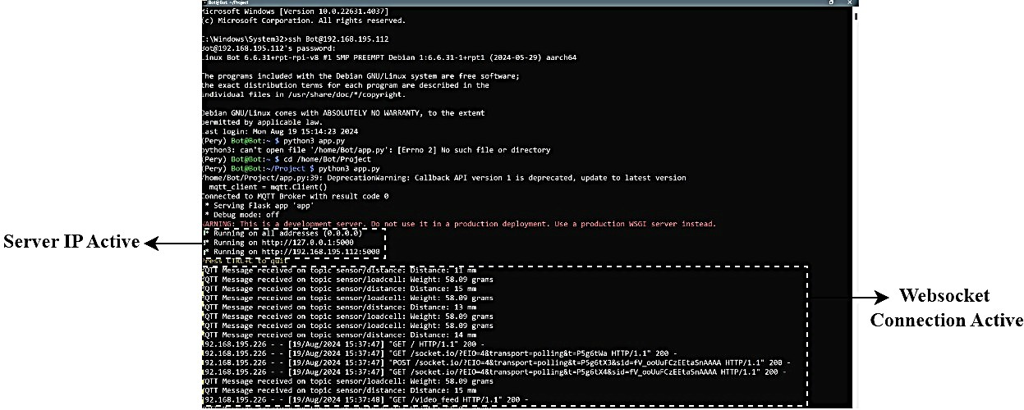

Figure 4 – Terminal Operation of Server Unit (Phase 1)

Per phase 2, we plan to perform PaaS migration, and enhance the structural functionality of the present setup, including motorized slider arrangement for deflection measurement across the beam length, in addition to a more intuitive software interface and hardware arrangement. We also plan to emphasize on the deployment of the higher-payload six degree-of-freedom cobot for manipulation as part of phase 2 (P2).
Expected start date for phase 2 – 02/09/2024

